Nexora member records and subscriptions
Document 9 of the Nexora learning guides
Source snapshot 14 October 2026 at 06:41 UTC
Understand the member listing, subscription detail, lifecycle changes and membership administration.

Recognise the screen and its scope
Open /membership/members, /membership/members/[id]. CRM routes use port 3017; member routes use 3018; public website routes can use 3019. Brackets name a route parameter, not text to paste into a browser. Choose a real record or site id from the application.
This guide covers Member list and detail; Join dates and rejoin selection; Renew cancel lapse and archive actions; Administration classifications and financial arrangements; Options joining fees and timeline.
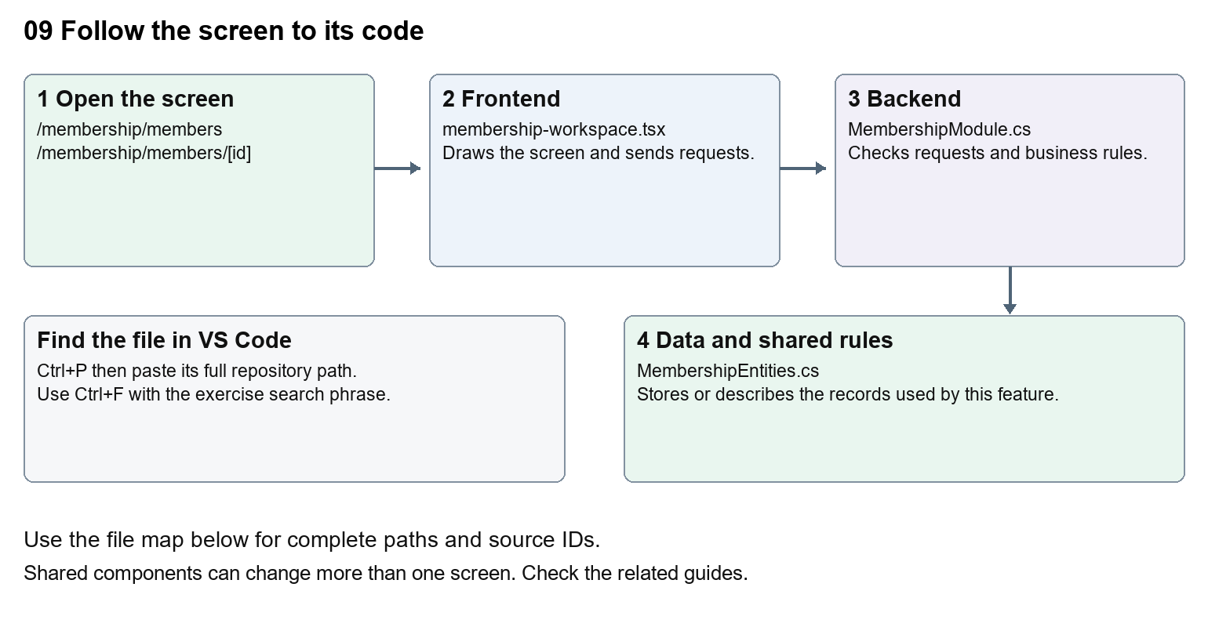
The diagram shows the file roles. The full paths below are what you paste into Ctrl+P.

Find the files in VS Code
Role | File and source ID | What it does
Screen | S0115 membership-workspace.tsx | Main UI or route for this topic
Server | S0512 MembershipModule.cs | Endpoints or server rules
Data | S0418 MembershipEntities.cs | Data shape or persistence structure

Screen S0115
apps/web/src/features/membership/membership-workspace.tsx
Server S0512
backend/src/Modules/Nexora.Modules.Membership/MembershipModule.cs
Data S0418
backend/src/Modules/Nexora.Modules.Membership/Domain/MembershipEntities.cs
The complete HTML manual opens these source IDs inside its Source library. The Word manual shows short labelled extracts so you can learn the flow before reading large files. Each individual Markdown guide includes its complete primary files after the walkthrough.

Follow the request and the records
1. The members route loads the staff session and required permissions.
2. MembershipList builds the member search, paging and sort request.
3. Opening a subscription loads its connected detail and administration sections.
4. A lifecycle action includes a version and reason.
5. The module validates the transition, saves changes and records history.

Read the code with an explanation
A Contact is not the same record as a subscription. The subscription links a subject to a product, term and status. Renewal, rejoin and cancellation rules belong in the server files, while individual frontend components edit dates, classifications and arrangements. Trace the id carefully: a Contact id and a membership id are not interchangeable.
Source reference S0115 apps/web/src/features/membership/membership-workspace.tsx
Selected opening lines with their original numbers. The complete file is in the HTML source library.
0001 "use client";
0002 import Link from "next/link";
0003 import { WorkspaceHeading } from "@/components/ui/workspace-heading";
0004 import { useRouter } from "next/navigation";
0005 import type { Route } from "next";
0006 import { ArrowLeft, Plus, Eye, Pencil, Trash2 } from "lucide-react";

The import lines lead to shared components and helpers. Start at the exported component or route function; follow the request helper to the server rather than assuming the whole feature lives in this file.
Source reference S0512 backend/src/Modules/Nexora.Modules.Membership/MembershipModule.cs
Extract from source line 54. A fragment from a long line is shown without the rest of that line.
0054 api.MapGet("/setup/{kind}", async (string kind, MembershipDbContext db, CancellationToken ct) =>

On the server, look for MapGet to load records, MapPost to create or perform an action, MapPut or MapPatch to change data, and RequireAuthorization for permissions. Some shared methods register endpoints indirectly. Find SaveChangesAsync to see the database write. A request method alone does not tell you every side effect.
Source reference S0418 backend/src/Modules/Nexora.Modules.Membership/Domain/MembershipEntities.cs
Selected opening lines with their original numbers. The complete file is in the HTML source library.
0001 using Nexora.BuildingBlocks.Domain;
0002 namespace Nexora.Modules.Membership.Domain;
0003 public sealed class MembershipProduct : TenantEntity
0004 {
0005 public string Name { get; set; } = "";
0006 public string Category { get; set; } = "";

Follow model fields to their request names and database mapping. An id points to a particular record. A tenant id limits the organisation. A version or concurrency stamp protects newer edits. Some model files describe contracts rather than tables; check the owning DbContext before assuming storage.

Make or trace your first change
1. Press Ctrl+P and open apps/web/src/features/membership/membership-workspace.tsx.
2. Press Ctrl+F and search for Member subscriptions. In this snapshot it appears at line 49.
3. Change the accessible table caption text only. Open the Members list and inspect its caption in browser accessibility tools. Leave tab names, routes and status values unchanged.
4. Replace only Member subscriptions with Membership subscriptions in that intended location. Keep quotes, tags, JSON keys and routes intact.
5. Save with Ctrl+S. Inspect Problems and the local screen. Review the diff and restore the original text when you finish practising.
Extract from source line 49. A fragment from a long line is shown without the rest of that line.
0049 t-sm"><caption className="sr-only">Member subscriptions</caption><thead><tr><th className="p-3"><inp

These exercises have not been applied to the application. Their search phrases are verified against the captured source. Line numbers can move; the phrase and file path are your main navigation aids.

Check a change and diagnose problems
Confirm the original screen still loads, the changed words appear in the intended place, and another screen using the same component still behaves correctly. If an action fails, inspect the browser Network response, the relevant helper and server validation message. Use the common error table at the beginning of the manual. Reload on a version conflict instead of removing the version check.
A syntax error after a text edit usually means a quote, brace or closing tag changed. Compare your diff with the original. An unchanged browser result can mean the wrong port, a saved published configuration overriding a default, or a running API that has not reloaded.

Understand the current limits
A stored membership term is not proof of collected payment. Versions guard against conflicting edits. Do not run cancellation or renewal on an active real member as a learning exercise.

Continue learning
Related guides 10 Nexora membership applications and decisions, 11 Nexora membership setup and products, 15 Nexora sales and finance, 25 Nexora member portal journeys.

